West Suffolk Council – Parish Council Report

Funding

Government has announced £1 billion of funding for local authorities this winter. As part of this package the Department for Digital, Culture, Media and Sport has also confirmed £100 million will be used to introduce a new fund to support council leisure centres most in need. West Suffolk still await details of what this actually means both in terms of our own important leisure facilities and wider support for the Council. Cabinet and the Council will be discussing the budget at our meetings in November. Hopefully by then fuller details will be available.

https://www.gov.uk/government/news/jenrick-confirms-allocations-of-1-billion-funding-for-councils-this-winter

Local Plan
The Council have now opened our virtual online exhibition to help put residents at the heart of shaping the new Local Plan, as agreed at Council.
The virtual exhibition in an online village hall (pictured) and includes a film as well as information boards and documents. The exhibition can be found at https://westsuffolk.exhibition.app/
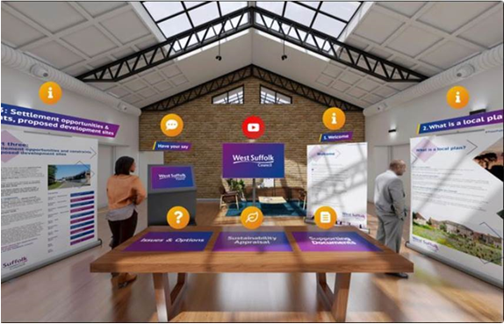
There are a range of methods being used to help people learn more and have their say which includes planning officers being available to talk online via livechat in the virtual exhibition space, or over the phone on 01284 757368.
The materials explain that a Local Plan should help local communities continue to thrive in the future by setting out not only where homes may be built but supporting , with other council policies where new jobs and other vital facilities could be located. All West Suffolk planning decisions are judged against Local Plan policies.
The Local Plan should ensure that the right number and types of homes are built in the right places and through its policies support the provision of space for employment, a healthy environment and green spaces, education, culture, health and sports facilities.
It also covers how infrastructure supports this growth and the challenges to be faced, such as climate change.
A good local plan is vital to prevent speculative development that could harm local communities, the countryside, and the environment and to ensure growth is well planned and supports our ambitions for the future.
The process involves three consultation stages with the first being the Issues and Options which started on 13 October and will last for 10 weeks.
This initial stage which will help shape the plan and the future of West Suffolk as it develops. The Issues and Options consultation also has three parts:
- Part One includes a spatial vision, a new draft settlement hierarchy and options for the distribution growth
- Part Two sets out issues in West Suffolk that are particularly relevant to our area, and
- Part Three contains sections for the towns, key service centres, local service centres and villages identified in the new draft settlement hierarchy in part one of the plan. It also includes a new call for sites.
At this first information gathering stage, the council will be consulting and seeking comments on a variety of issues and options. This includes questions such as have we identified the challenges and relevant local issues correctly, as well as whether we have covered all the options for delivering growth.
Welcome to Local Plan (full): https://youtu.be/XwXFW91yuI0
Welcome to Local Plan virtual exhibition: https://youtu.be/JejfevaGu5Q

Crest

In January 2019, the Shadow West Suffolk Council proposed that the new West Suffolk Council adopted the Coat of Arms, held by the former West Suffolk Council until 1973.

As you might expect this is a long process that dates back hundreds of years. But the council has been notified by the Windsor Herald that the certificate has been transferred and quoting from their letter: “issued by the King of Arms pursuant to a Royal Licence granted by the HM The Queen” I include a picture of it below and attach a copy of the official document that is now recorded in the College of Arms London.

The Coat of Arms is made of a number of elements that reflect the heritage and history of the whole of West Suffolk showing our links back to the Magna Carta and beyond, including St Edmund and the Suffolk Regiment which was based here. Finally, the motto, for King Law and People, is translated from the Magna Carta, reflecting its strong links to the area.

This does not replace the Council’s logo but is used for civic occasions.

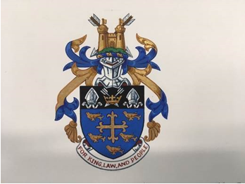
Free School Meals

While Suffolk County Council have not provided the Government-funded vouchers to schools for Free School Meals over this half term week, they are supporting families and children in need as collectively we don’t want any child to go hungry.

In August, DEFRA awarded Suffolk County Council £770,000 as their share of the hardship grant. Suffolk Public Sector Leaders provided further match funding of £800,000 in September. So far, the Suffolk system has spent £600,000 and this covers:

- The Local Welfare Assistance Scheme, which funds supermarket, food and fuel vouchers, school uniforms, essential furniture items, white goods, and oil heating refills
- The Suffolk Advice and Support Service phoneline https://www.suffolk.gov.uk/coronavirus-covid-19/suffolk-advice-and-support-service/
- A donation of £100,000 to the Suffolk Community Foundation to provide grants to organisations to help communities with immediate hardship

Environment
West Suffolk campaign goes national
A campaign run in by West Suffolk Council and local schools to try to cut harmful toxic emissions from vehicles, has been turned into a national initiative.
Idling occurs when a driver is parked with their engine running. Where it happens outside schools, it exposes children to excessive toxic fumes. Long term exposure can cause asthma in children and stunt their lung growth, which can impact on their health for the rest of their lives.
Earlier this year, the Council worked with Cool World Consulting to take the anti-idling message into four schools. All four schools - Guildhall Feoffment Primary School and St Edmunds Primary School in Bury St Edmunds, Great Barton Primary School and West Row Academy – came forward after the Council , in 2019, announced it was looking to work in partnership with schools where idling is an issue.
Now Cool World Consulting has used the work in West Suffolk to develop its national initiative Cleaner Air Sooner, which has been backed with funding from the international philanthropic organisation, the Clean Air Fund.
The campaign worked with students to educate them on the dangers of vehicle idling, so that they would then pass that message to their parents, grandparents or other guardians. All four schools held a special assembly which looked at the issue of idling, pollution and health. School children then designed their own posters to help spread the message that idling is bad for their health. Pupils in each of the schools’ road safety teams, together with teachers and council environment officers, patrolled the streets outside their schools, thanking drivers who weren’t idling and asking drivers who were, to switch off. They also handed out leaflets and car stickers to motorists. The Council meanwhile sent information to other schools across West Suffolk.
Lucy Harbor from Cool World Consulting summed it up by saying: “The campaign in West Suffolk showed just how effective children are at encouraging behaviour change. One hundred per cent of the drivers they spoke to switched off their engines, helping the pupils in Suffolk to breathe cleaner air. We are delighted that this now features as one of the case studies in our programme. And our toolkit for idling, which is now being promoted to schools across the country, builds on the learning from the project in West Suffolk”.
Nationally idling is linked to air pollution which Public Health England estimates is a contributory factor in some 40,000 early deaths every year.
Gaia
The Gaia earth exhibit at The Apex, has been a tremendous success in terms of people visiting and supporting the venue as well as supporting local businesses and thinking about the environment.
Nearly 13,000 visitors came to see Gaia which features detailed NASA imagery of the Earth’s surface and provides the opportunity to see our planet as if from space. A specially made surround sound composition by BAFTA award winning Composer Dan Jones was played alongside the sculpture.
The exhibition ran from 3 October through to Sunday 18 October with 12,898 visitors attending during that time. It is the first event that The Apex, run by West Suffolk Council, has held there since lockdown. Social distancing measures were in place and people had to book time slots.
Alongside the exhibition we ran display boards as well as digital content of the work West Suffolk is doing to tackle climate change. In addition, following our taskforce’s recommendations, the exhibition challenged and engaged with residents to think about what pledges they could make to reduce their impact. The Council will be using the displays again and on social media.
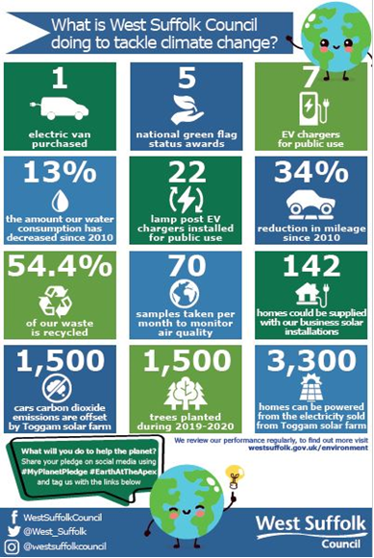

Following the success of Gaia, The Apex management is currently looking to introduce a series of reduced capacity live shows ensuring, as with Gaia, that customer and staff safety remains paramount.
If you missed out, here is a brief film: https://youtu.be/0HBSFJVE4WA
Flagging success in green awards
The six parks in West Suffolk, which more than ever play an important role in people’s physical and mental well being have been awarded the prestigous Green Flag in recognition for being safe, clean and well looked after.
The West Suffolk Green Flag winners are:
- Abbey Gardens in Bury St Edmunds
- Aspal Close Nature Reserve, Beck Row
- Brandon Country Park,
- East Town Park, Haverhill,
- Nowton Park
- West Stow Country Park
The pandemic has meant that West Suffolk’s parks and green spaces have never been so important. While they have always been popular, the council managed to keep them open during lockdown and people were able to get out to our parks to exercise, to walk and to mentally recharge. The importance of this, at what has been a time of huge strain on us all, cannot be underestimated. The proactive management of our parks and green spaces is part of what makes West Suffolk such a desirable place to live and work as well as conserving natural habitats and increasing biodiversity.
The Green Flag Award scheme, managed by environmental charity Keep Britain Tidy under licence from the Ministry of Housing, Communities and Local Government, recognises and rewards well-managed parks and green spaces, setting the benchmark standard for their management across the United Kingdom and around the world. It operates in the UK and an additional 14 countries including Portugal, New Zealand and USA.
The green energy helping power Mildenhall Hub
A battery the size of a shipping container made from recycled electric vehicle batteries, is among the green features that will help power the Mildenhall Hub with renewable energy.
A new school, leisure facilities including new pools, a health centre, advice centre, library and office space for public sector partners will all come together in the hub, which will open in 2021.
That future includes greener, cleaner energy with the hub design making the most of its environmental features.
Heating a swimming pool uses a lot of energy. But a Ground Source Heat Pump (GSHP) offers the prefect solution. By pumping water down into the ground where it will naturally warm, and then using this heated water pumped back into the pools, significant greenhouse gases and money savings will be made.
A Combined Heat and Power (CHP) unit combines a boiler and electricity generator into one. It generates electricity while heat created as a by-product will be used for the hot water for the rest of the hub building as well as heating the pool air and toward heating the overall building.
The Mildenhall Hub will also benefit from around 600 solar panels generating electricity during daylight hours, while a large 300kW battery called an E-STOR, made using 24 second-life Renault Kangoo electric vehicle batteries, offers the chance to store any excess energy generated by the panels and CHP. It can then switch to that onsite generated renewable energy at peak times, saving costs in the process.
Domestic Energy Efficiency : Update and Opportunity

As you know, West Suffolk Council has declared a climate change emergency and Cabinet has agreed a road map of initiatives to protect and improve the local environment and set us on the road to become net-carbon zero by 2030.

As part of this, the Council is also supporting the residents and communities of West Suffolk to improve their own home energy efficiency.

The Green Homes Grant.

Grants of up to £5000 or £10,000 are available and will cover two-thirds of the cost of qualifying home improvements. These include loft, cavity and external wall insulation, along with solar and heat pump renewable energy systems. For more information see https://www.simpleenergyadvice.org.uk/pages/green-homes-grant

Also on offer is Suffolk Greener Homes Interest Free Loan loans of up to £5,000 at 0% APR to help homes cut their energy use. Loans are available for energy saving measures but are only available for the installation of approved materials and technologies by accredited installers. For more information see http://www.greensuffolk.org/at-home/energy/loans-for-energy-efficiency/

Hybrid heat pump pilot project

The renewable heat incentive (RHI), a subsidy scheme to promote the use of renewable heat technologies including solar thermal and heat pumps. Under this scheme the resident must fund the initial installation cost, but will receive quarterly payments for 7 years based on the amount of renewable heat generated in the home heating system. For more information see https://www.ofgem.gov.uk/environmental-programmes/domestic-rhi

One alternative to completely replacing your existing boiler and radiators is to install a hybrid heat pump system. A new heat pump can be installed to provide the majority of the heat required to heat your home but is supported by your existing boiler for particularly cold days or where your heating demand is high. This approach avoids you needing to replace any radiators and is supplied with a sophisticated control system to automatically switch between systems. EDF, an energy provider, is currently offering a scheme to deliver the installation of a hybrid heat pump system to residents with an existing oil or LPG central heating system. The resident is required to pay a small deposit and EDF will fund and manage the installation of the heat pump. EDF then claim the Government’s renewable heat incentive to cover the installation cost.

Business Support

Grants

Final payments have been made under the Government and Council schemes to businesses – supporting thousands of West Suffolk businesses access millions of pounds of help during lockdown.

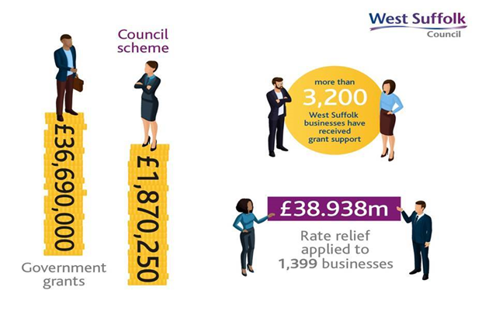

Cornhill Development
The historic frontage at 17-18 Cornhill, the former post office, is being kept while the rest of the building behind, including parts which were added on at a later stage, is gradually being demolished.
The redevelopment, being carried out by Suffolk firm Barnes Construction working with its appointed architects, Concertus Design and Property Consultants, will deliver new ground floor commercial units with 12 flats above. By widening Market Thoroughfare by over 50 per cent and creating a new commercial frontage onto St Andrews Street South, the Council will also be delivering on some of the aims of the town centre masterplan, shaped by 8000 public comments.
One of the first steps of course is ensuring the protection of the historic Cornhill front, a job for Barnes’ structural engineers Superstructures.
Test and Trace Support Payments
Government has introduced Test and Trace Support Payments to provide financial aid to some people, such as those on low incomes and benefits, who have been asked to self-isolate. Councils, such as ours, have been asked by Government to administer this system.
Below is the link providing details of these payments.
https://www.westsuffolk.gov.uk/coronavirus/test-and-trace-support-payments.cfm
If you have been contacted by NHS Test and Trace and have been told to self-isolate, you may be entitled to financial support. You must meet all the following eligibility criteria, to be entitled to a lump sum payment of £500:
- You have been told to self-isolate by NHS Test and Trace on or after 28 September 2020.
- You are employed or self-employed.
- You cannot work from home and will lose income as a result.
- You are currently receiving at least one of the following benefits: Universal Credit, Working Tax Credit, income-based Employment and Support Allowance, income-based Jobseeker’s Allowance, Income Support, Housing Benefit and/or Pension Credit.
- Made your application within 14 days of the last day of your NHS test and trace self-isolation period.
Applications are for one person only and any further applications within the same household must be made by each individual.
Payments are subject to tax but not National Insurance.
Please make sure that you have the following information available before starting the application:
• National Insurance (NI) number.
• Your eight digit Test and Trace ID number. (We are currently waiting for Government to allow access to their Test and Trace system. But please do not delay in making your claim as your application will be processed as soon as we have that access.)
• Your most recent bank statement, proof of self-employment or wage slips as well as proof of receipt of one of the qualifying benefits.

